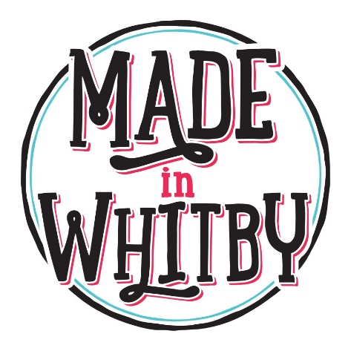
Made in Whitby – Supporter Application Form
Please only apply if Made in Whitby criteria, terms & conditions have been read and agreed to, this can be found on our website.

Your name

Business/trading name

Business address

Business postcode

Contact telephone number

Email address

Social media links

Brief description of your products

Is the product(s) made/produced/sourced within the YO21 OR YO22 postcode catchment area?

Does the item/products you make & sell meet our criteria?

Do you agree with our Supporter terms & conditions?

Please add details and send/attach 7 images you feel best represents your business/product

Many Thanks,
Made in Whitby

